Take YOur Next Step and Join a Grow Group  Trinity Baptist Church’s Mission:  Knowing Jesus and Making Him Known.  We accomplish this mission by Knowing who Jesus is and who we are as followers of Jesus, Growing with Jesus and in thriving community with other believers, and finally, Going with Jesus on mission to bring people to saving knowledge of Jesus Christ.  What to expect when you join a Grow Group here at Trinity  The unified three-fold purpose of Grow Groups is to:  Grow in Maturity as a Believer in becoming more like Jesus  Grow in Community with other believers in friendship and love, and  Growing Numerically by reaching and inviting others to Know Jesus and Make Him Known.  Are you Ready to Grow?  Fill out some information and put it in the offering plate or give this to the pastor:  Name_______________________________  Best Contact (email, Phone, etc.)  ____________________________________  Which Group Would You Like to Join? (circle one inside or list here)  _____________________________________ | 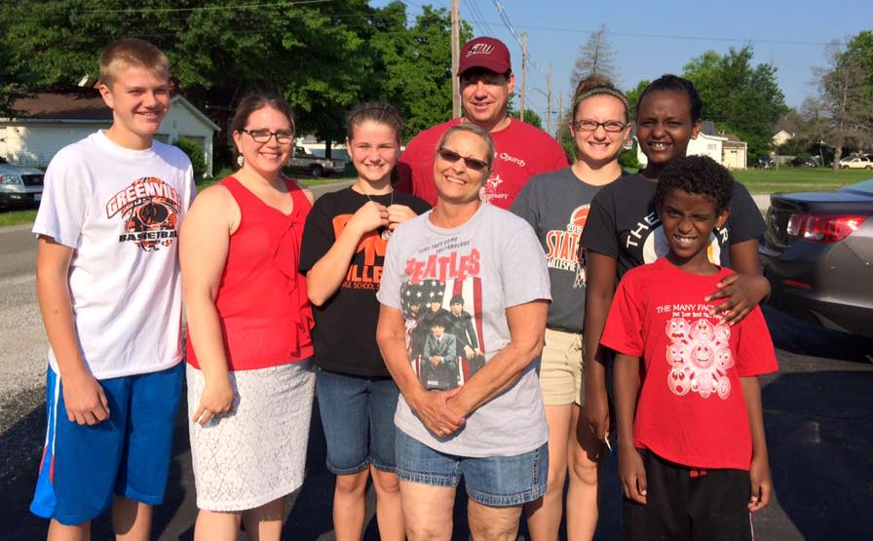  Come Check us out!  Sunday Mornings  Sunday Grow Groups – 9:30am  Morning Worship – 10:30am  Sunday Evenings  Youth and Children Ministries – 6pm  Wednesday Evenings  Grow Group Gathering – 7pm  Contact Us  Church Phone: 217-839-3667  Email: TBCGillespie@gmail.com  Web: www.trinitybaptist-illinois.com  Find us on Facebook!
Sunday Morning Grow Groups  9:30-10:20 A.m. @ Trinity Baptist Church  HIgh and Jr. High School  Life is difficult. It doesn’t always go as planned. Where is God in all of it? What does He want me to do in all of it? Your life matters and has purpose. God has an awesome plan for your life. Come see what God has to say to you and see where He will take you next!  Tracie Kirkwood (Leader)  Preteens and Children  This group is a safe and healthy group for your K-4th grader. We always love to have fun, enjoy God, and open His word to see what He has to say in this interactive, growing group. Your child may be asking some tough questions about God, life and who Jesus is. We want to help!  Karen Wayman (Leader)  Babies and Pre-KinderGarten  This is a safe and interactive place for your child to be prayed for, to hear the bible read to them and to meet new friends. All teachers and helpers have been checked and cleared to serve by DCFS of Illinois and have a heart for loving your children with the unfailing love of Jesus Christ, our Savior.  Debbie Deck (Leader) | Sunday Morning Grow Groups  9:30-10:20 A.m. @ Trinity Baptist Church  Couple & Single ADults  This multifaceted group gathers for the purpose of life transformation and study of how the bible applies to your life. Whether you have children or not, married or not, God wants to meet you where you are and develop you into a man or woman in His likeness for His greater purposes. Life is busy, confusing, troubling, and is desperate for intervention from God. Join us!  Mark and Dani Massey (Co-Leaders)  Senior Men  This group of men is committed to the bible and what it means to follow Jesus. You will find a wide range of men from different backgrounds that desire to know what God says and how to live it out for others. Take the next step and join this group!  Kenny Harbaugh (Leader)  Senior Women  You will not find a godlier group of women that love Jesus, on mission to serve others, and enjoy their time together. Join the laughter, the learning, and come discover what it means to live out your life for the glory of God.  Roberta Kinder (Leader) | WeekDay and Other Grow Groups  Various Times in Various Homes  mens  You are invited to join this men’s group of all ages. If you are a guy that loves food, doesn’t have everything figured out, this is a group for you! This growing group gathers for a meal and study that anyone can understand. Come and see!  Time/Place: 6-8pm on Thursdays  Rick Konneker (Leader)  Womens  God wants you to be a part of this women’s group to learn how to face life’s pains, grief, and anxieties. You are valuable, worthy, and accepted woman by God. Come see what to do next! Time/Place: 1pm on Thursdays.  Della McFarlane (Leader)  YOung Couples  If you haven’t joined yet, you are missing out on an amazing group here! Are you a young couple ready to grow in your life with Christ? Don’t have everything figured out? God does, and this group is just for you!  Jerry and Haylie Crites (Co-Leaders)  MULTIGENERATION COUPLES  Come be a part of a great bible study here! Acceptance, love, care, prayer, and the power of God’s Word in our lives is a common theme here! Time/Place: 6pm on Thursdays  Gary and Fran Smith (Co-Leaders)

